- Install Python (latest version) and VS Code on your system, then take a screenshot of both the Python installation confirmation and the VS Code welcome screen.

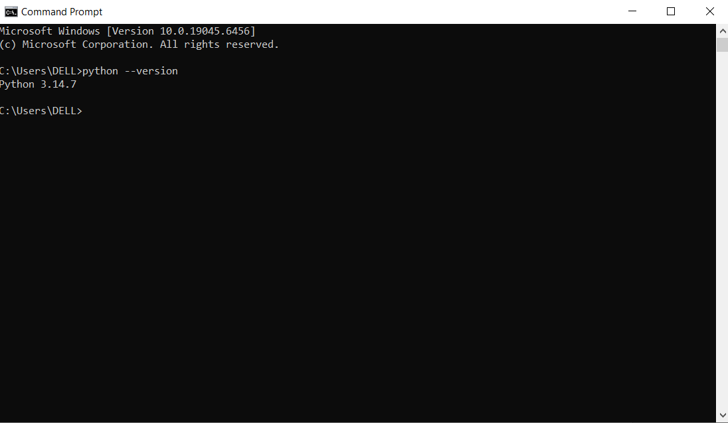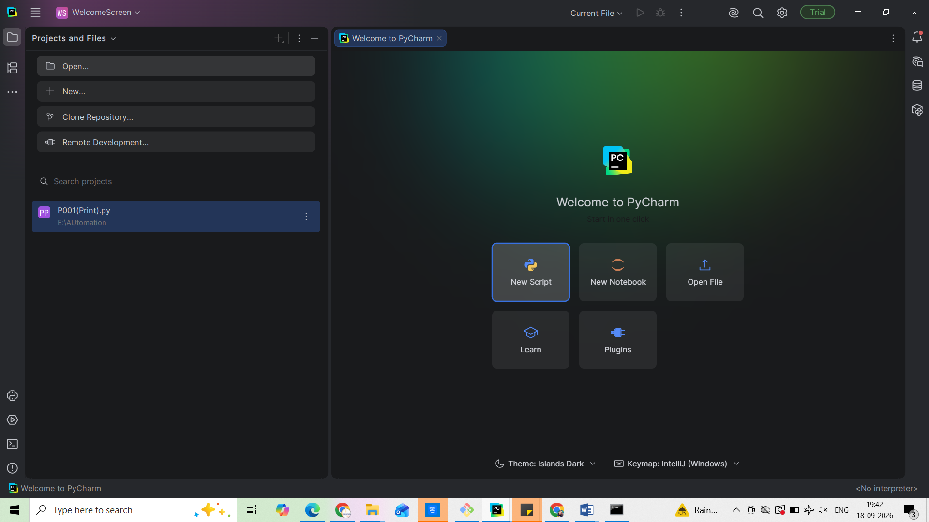

- Create a new folder named InstaTestProject, open it in VS Code, and set up a Python virtual environment inside it using the venv module.
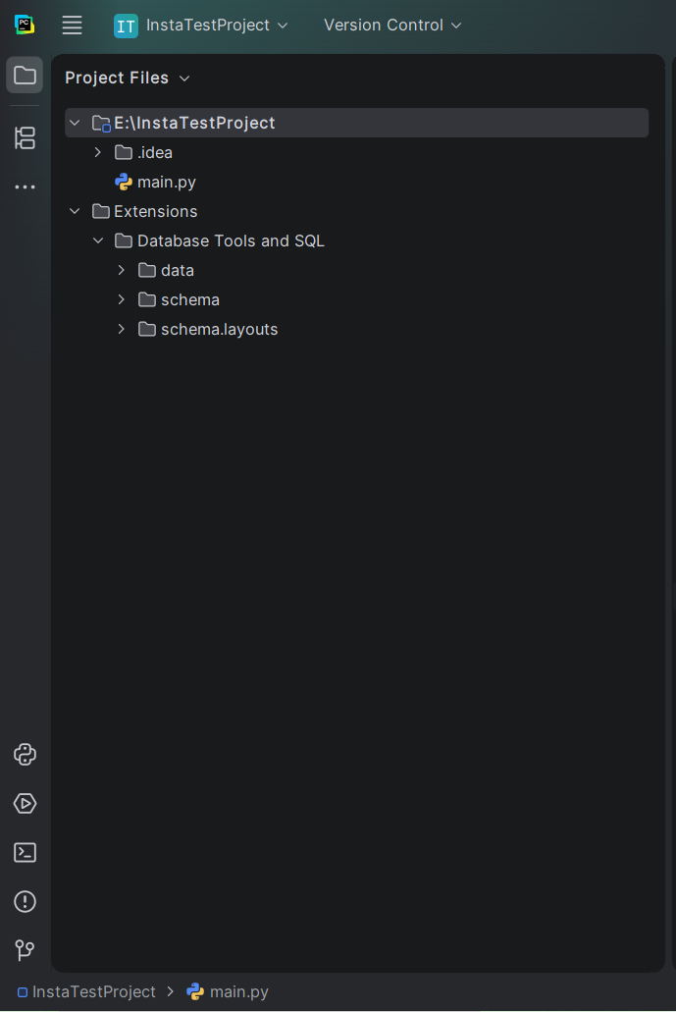
- Use pip inside your InstaTestProject virtual environment to install the requests package, then run 'pip list' and note the installed packages.

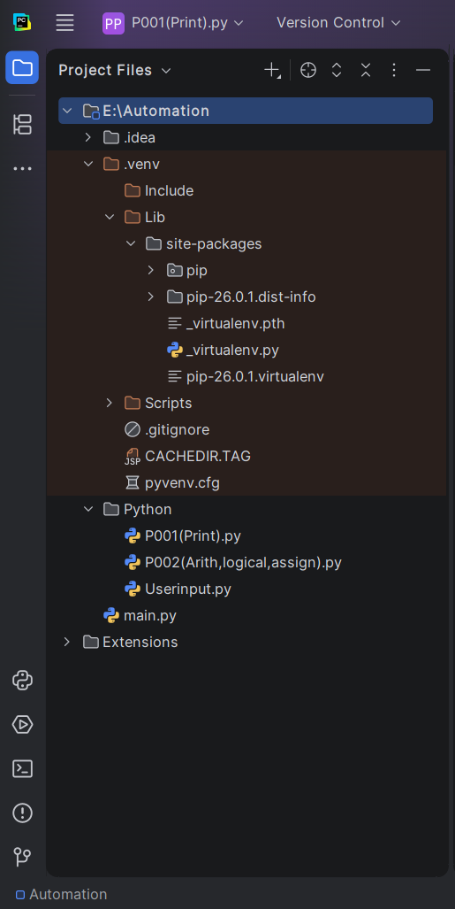
- Write and run a Python script named hello_automation.py that prints 'Hello, Automation Tester!' and the current Python version being used.<br><br><em><strong>Hint:</strong> Use the sys.version property to display the Python version.</em>

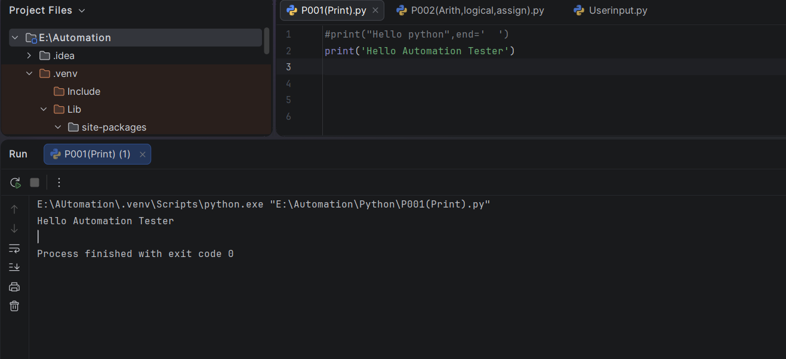

- Explain in 3-4 lines how using a virtual environment (venv) helps when working on multiple automation projects, especially if you need different package versions for each.

- It allows each project to use different versions of packages without affecting other projects.
This prevents dependency conflicts and makes projects easier to manage and reproduce.

